Morphology and Electrical Signal Sensitivity of Soft Porous Collagen – Hydroxyapatite Inkjet Printed Film Used for Bio Marker
John Goodman^{1,*},Issarawadee Gobkham²and Jiang Shun Li³

¹Department of Radiology, University of Wisconsin - Madison, Madison, WI 53705, USA
²School of Chemistry, Institute of Science, Suranaree University of Technology, Nakhon Ratchasima, 30000, THAILAND
³Institute of Functional Nano & Soft Materials (FUNSOM), Collaborative Innovation Center of Suzhou Nano Science and Technology, Soochow University, Suzhou, Jiangsu 215123, China

*Corresponding Author’s E-mail: jgoodman@u-wisconsin.edu

Abstract

Generally, both collagen and hydroxyapatite are the main components of the natural bone. Therefore, this study aimed to produce soft porous three-dimensional collagen-hydroxyapatite composite scaffolds by a freeze drying technique. The porous structure of the collagen-hydroxyapatite scaffolds have also been modified by adding vitamin E as a pore former with different concentrations. The lyophilized porous samples were stabilized using chemical cross-linking. Morphology, porosity and density, of materials have been studied by using SEM and micro-CT, respectively. Due to its high surface area, the electrical response properties and textural properties were tested under compressed twice at 25% IFD using a texture analyzer to monitor the behavior of the scaffolds when compressed. The behavior of the scaffolds were then reported and discussed in the term of young’s modulus, cohesion energy and springiness. The results revealed that all samples of the composite scaffolds showed a good electrical response characteristic and flexibility properties.
Keywords:Inkjet printing, Collagen-Hydroxyapatite thin film, Electrical response, Bio-marker, Vitamin sensitivity.
Introduction
Graphene is a monolayer two-dimensional (2D) honeycomb lattice of sp2-hybridized carbon atoms. Since its discovery in 2004, graphene and graphene derivatives such as, graphene oxide (GO), reduced graphene oxide (rGO), and functionalized graphene have been one of the most exiting topics in material science and man research fields because of its excellent mechanical, electrical, optical, and thermal properties [1,2,3]. These unique properties make graphene and its derivatives having great promising potential applications, for example, nano-electronics, nano-composites, energy and gas storages, water separation, sensors, and solar cells [4-5]. Thus the synthesis of graphene has been one of the hottest topics scientific communities with the goal of making large quantities of high-quality graphene in a cost effective manner.
Experimental Procedure
Materials
Polyacrylonitrile (PAN, Mw 150,000) was used as the polymer source. Paraffin oil was used as the agent to make pores in the CNFs. N’ N-dimethylformamide (DMF) was used as a solvent of the shell-electrospinning solution. An electrochemical cell was performed in potassium hydroxide (KOH) electrolyte. The materials in this study were purchased from Sigma-Aldrich (USA).

Fabrication of Electrospun CNFs
Solution preparation. Scheme 2 represented the whole procedure of material preparation including preparation of the solution, electrospinning, and calcination. The precursor solution was prepared by dissolving 8 wt% PAN in DMF. After being strongly stirred at room temperature for 2h, the solution was ultrasonicated for 1h at room temperature and subsequently stirred overnight at room temperature to get the homogeneous solution, which was ready for electrospinning.
Electrospinning of nanofiber. The homogeneous precursor solution and paraffin oil were loaded into 10 ml plastic syringes and then inserted into the homemade core-shell electrospinning system as a shell and core solution, respectively. The feeding rate of the pump is 0.5-0.6 ml h-1 and the applied voltage was between 7 and 10 kV.

Characterization
The external morphology of sample was observed by using field emission scanning electron microscope (FE-SEM JEOL JSM 7800X). The specific surface area and the pore character were investigated by gas adsorption/desorption technique by using automatic specific surface area/pore size distribution analyzer BELSORP-mini.

Results and Discussion
In this work, all chemical structures as well as the synthesis steps of graphite oxide, graphene oxide (GO), and reduced graphene oxide (rGO) nanosheets from pristine graphite are proposed and also illustrated in Fig. 1. As shown in the figure 1, the pristine graphite is firstly oxidized to graphite oxide by KMnO4 and H2SO4 acid, which it containing of some oxygen-functional groups such as, hydroxyl, carbonyl, carboxyl, and epoxy groups. Then, a dark-brown GO aqueous suspension was obtained by dispersing graphite oxide in distilled water under sonication, and then centrifugation, respectively.
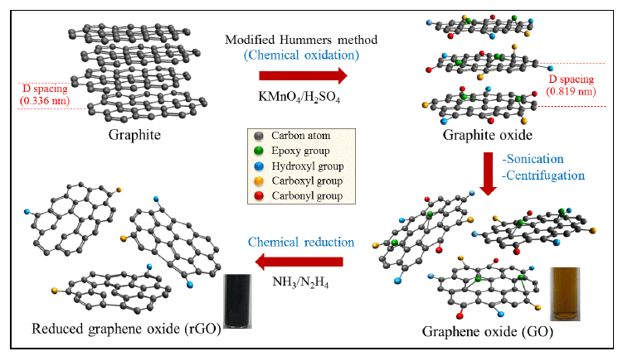
Fig. 1 Illustration of the synthesis processes of graphite oxide, graphene oxide (GO), andreduced grapheneoxide (rGO) from pristine graphite.

To confirm the crystal structures and interlayer d-spacing of graphite, the obtained GO and rGO samples, XRD technique was carried out and the results are presented in Fig. 2. It can be observed that the graphiteexhibits a sharp diffraction peak at 2θ = 26.5˚ (see in Fig. 2a), corresponding to a typical diffraction of the (002)graphitic carbon plane [5,16].

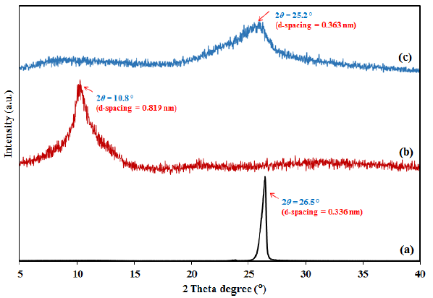

Fig. 2 XRD patterns of (a) pristine graphite, (b) graphene oxide, and (c) reduced graphene oxide.

CNFs has mean pore diameter of 14 nm which is the diameter of mesompore while PCNFs has mean pore diameter of 1.8 nm which the diameter of micropore. Among the two samples, PCNFs has much higher specific surface area of 677m²/g. Unfortunately the value of specific areas getting from BET technique for materials which have micropores (pore size less than 2 nm) and small mesopore have errors because for this kind of materials the measured isotherm is a weighted average over the adsorption due to the effects of pore size, pore shape, active adsorption sites, and blocked and networked pores [20, 21]. Other parameters are listed in Table 1.

Table 1. The textural parameter CNFs and PCNFs obtained by BET, BJH, and MP methods.
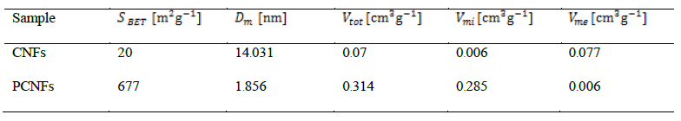

To calculate the parameters related to textural properties observed, Eq. 1 and 2 are employed.

C² = a² + b² (1)
(2)

Conclusions
We can fabricate CNFs and PCNFs by using PAN and PAN-paraffin oil, respectively, by core-shell electropinning system successfully. The paraffin oil can produce a lot of micropores in Carbon nanofibers which could improve the cyclic stability up to 99.5% remaining after 1000 cycles. However, the micropores do not improve the specific capacitance due to the size of the pores is too small for KOH-electrolyte ions to access. Thus, other electrolytes should be considered for this material. By the same technique, other solutions or materials will be selected to replace paraffin oil in the future works to make mesopores and macropores in carbon nanofibers which could improve specific capacitance.

Acknowledgments
The author would like to thank School of Physics, Institute of Science, Suranaree University of Technology for all support in this work. IssarawadeeGobkhamwas supported by SUT-PhD Scholarship Program for ASEAN. This work has partially been supported by the Nanotechnology Center (NANOTEC), NSTDA, Ministry of Science and Technology, Thailand, through its program of Center of Excellent Network.
References
[1] J. van der Geer, J.A.J. Hanraads, R.A. Lupton, The art of writing a scientific article, J. Sci. Commun. 163 (2000) 51-59.
Reference to a book:
[2] W. Strunk Jr., E.B. White, The Elements of Style, third ed., Macmillan, New York, 1979.
Reference to a chapter in an edited book:
[3] G.R. Mettam, L.B. Adams, How to prepare an electronic version of your article, in: B.S. Jones, R.Z. Smith (Eds.), Introduction to the Electronic Age, E-Publishing Inc., New York, 1999, pp. 281-304.
[4] R.J. Ong, J.T. Dawley and P.G. Clem: submitted to Journal of Materials Research (2003)
[5] P.G. Clem, M. Rodriguez, J.A. Voigt and C.S. Ashley, U.S. Patent 6,231,666. (2001)
[6] Information on http://www.weld.labs.gov.cn

